AUTOMATIC CONVEYOR BELT
SORTING SYSTEM
MEMBERS
1
2
3
.MERCY MARGARET MUTANU-EE107/G/13973/21
.WAMBUA MUMBUA-EE107/G/13975/21
.OMONDI CHRISTABEL PASCALIA-
EE107/G/14012/21
SUPERVISOR:ENG RODGERS BOSIRE


BACKGROUND OF STUDY
➢
➢
Industries require efficient sorting of objects on
conveyor belts for manufacturing, logistics,
recycling, and food processing.
Manual sorting and traditional conveyor systems
are time-consuming, prone to errors, and
inefficient.
➢
➢
➢
➢
Increasing production volumes demand more
precise and automated sorting mechanisms.
Accuracy Issues: Difficulty in correctly classifying
and sorting items.
Efficiency Concerns: Manual sorting slows down
operations and reduces productivity.
Cost Implications: High operational costs due to
errors and inefficiencies in existing sorting
processes.


OBJECTIVES
MAIN OBJECTIVE
➢
➢
The objective was to develop a system that was
cost-effective, efficient, more accurate, and
reduced human labor.
SPECIFIC OBJECTIVES
To create a system that was capable of
classifying objects of numerous types with precise
accuracy.
➢
➢
To create a system that optimized performance
and reliability.
To apply improved sorting processes by utilizing
more accurate sensors and imaging techniques


METHODOLOGY
SOFTWARE DEVELOPMENT AND SIMULATIONS
The software component was developed using Arduino
programming to control the system's sensors, motors, and
actuators
➢
Fig.1Simulation diagram
Fig. 2 CAD design
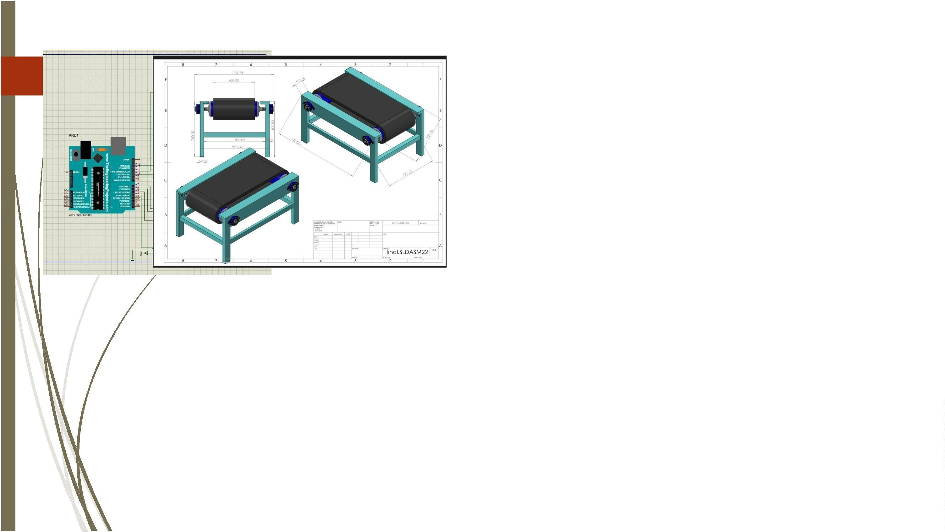

IMPLEMENTATION AND TESTING
HARDWARE IMPLEMENTATION
➢
The hardware was designed and implemented with the following key components:
➢
➢
Arduino Uno
TCS3200Color Sensor
Servo motor SG90
Ultrasonic sensor
Dc Motor
➢
Motor driver L298N
Breadboard
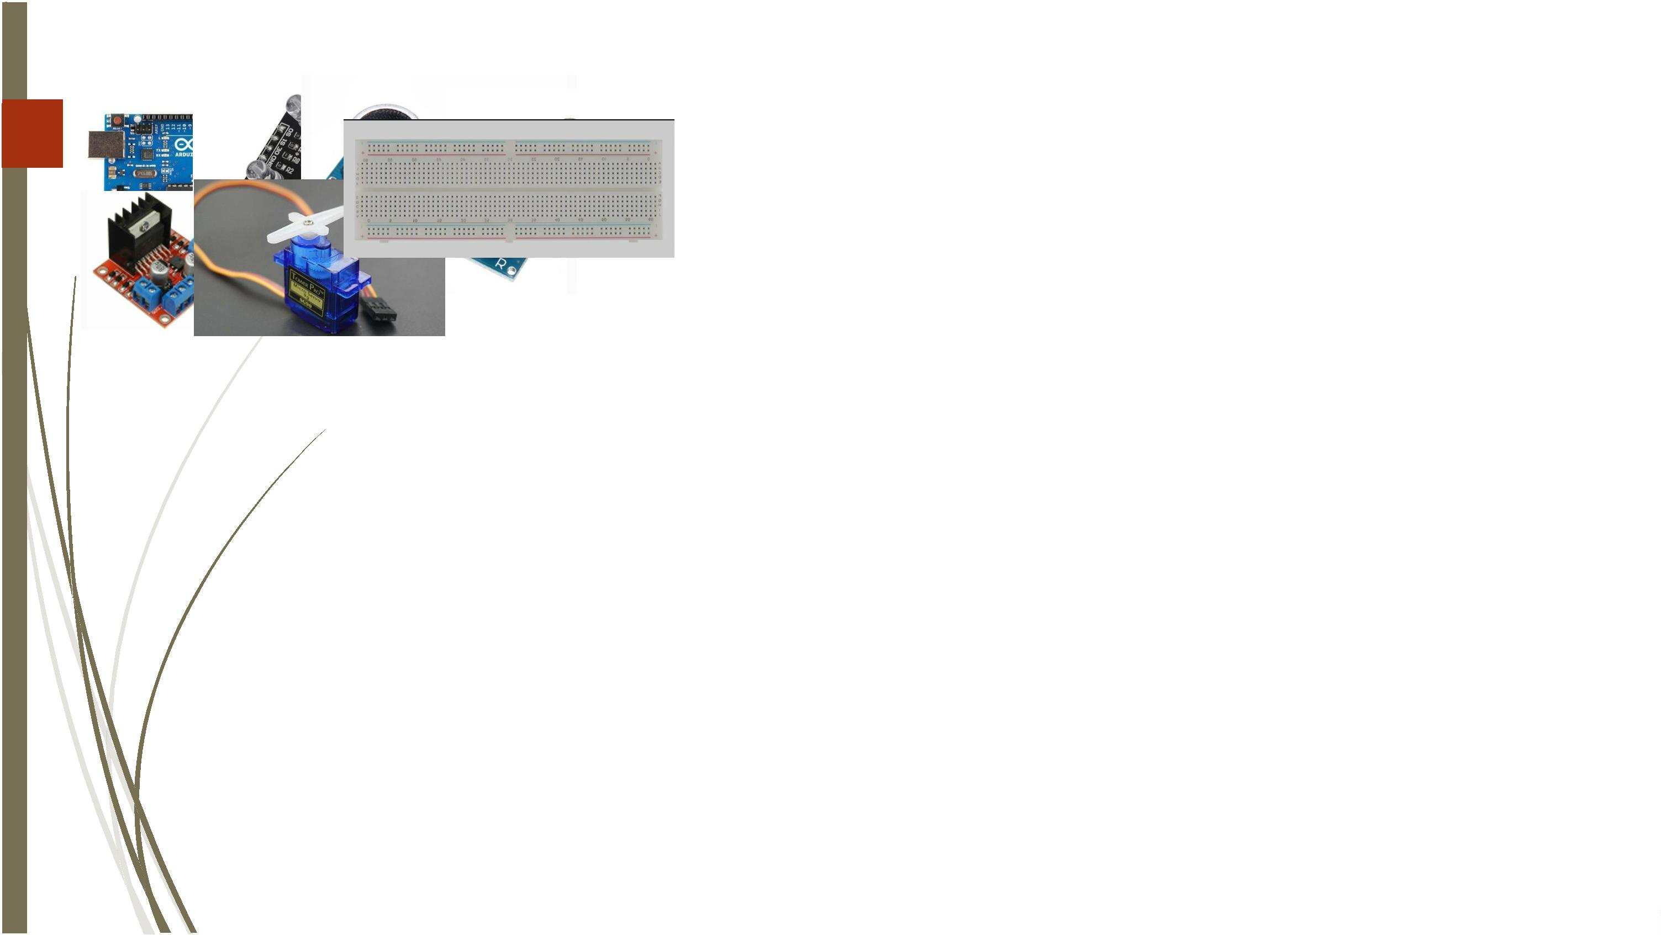

IMPLEMENTATION DIAGRAM
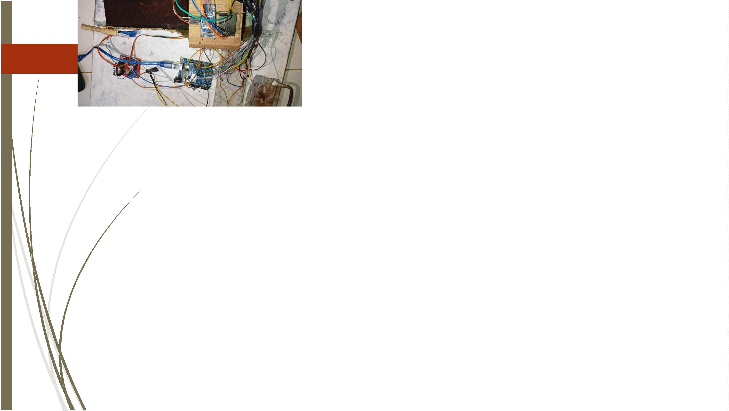

RESULTS AND DISCUSSION
➢
The system was tested for accuracy, speed, reliability, and efficiency.
➢
➢
➢
➢
It aimed to detect, classify, and sort objects based on color.
Components used: ultrasonic sensors, TCS3200 color sensor, servo motors, and DC motors.
Performance was compared against expected outcomes.
Limitations and discrepancies observed during testing were analyzed.
RESULTS
COLOR DETECTION ACCURACY
➢
The color sensor was tested by placing multiple objects of
different colors under varying lighting conditions. The
detection accuracy was recorded as follows:
Red objects: 92% accuracy
Blue objects: 94% accuracy
Other colors: Misclassification rate of 8%
➢
➢
➢
➢
➢
The slight variations in accuracy were mainly attributed to
good lighting conditions affecting sensor readings.
Calibration adjustments helped in improving detection
reliability.


SORTING EFFICIENCY
The sorting mechanism, controlled by servo motors, was
assessed based on response time and correct placement of
objects.
➢
➢
The system successfully sorted 93% of the tested objects into
their correct bins, with occasional misplacements due to
conveyor speed variations.
SPEED ANALYSIS
The conveyor belt's speed was optimized to balance
efficiency and accuracy.
➢
➢
The average sorting time per object was recorded as 2.5
seconds, ensuring a steady flow of items without
congestion.


DISCUSSION OF RESULTS
➢
➢
The results indicate that the automatic conveyor belt sorting
system performed well in color detection and object sorting.
The accuracy levels met expectations, though minor
calibration and environmental adjustments could improve
overall efficiency.
➢
➢
➢
The color sensor was effective but slightly affected by
lighting conditions. Enclosing the sensor in a controlled
environment could reduce misclassification.
The successfully directed objects into their designated bins,
though occasional misplacements were observed due to
conveyor speed inconsistencies.
The system’s overall efficiency was high, demonstrating its
potential for industrial applications, with further refinements
enhancing its robustness.


CONCLUSION
➢
➢
The system successfully detected, classified, and sorted objects based on color.
Achieved 93% sorting efficiency using ultrasonic sensors, TCS3200 color sensor, servo motors,
and DC motors.
➢
Minor issues arose due to environmental factors like poor lighting.
➢
➢
Automation in sorting improves efficiency, reduces human error, and boosts productivity.
Further improvements can enhance performance and scalability for larger applications.


RECOMMENDATION
➢
➢
Based on the findings of this study, the following
recommendations are suggested for improving the system:
Enhanced Calibration: Regular calibration of the color sensor
should be implemented to reduce errors caused by
environmental variations.
➢
➢
➢
Enclosure for Sensors: Placing the color sensor in a controlled
lighting environment will minimize misclassification due to
ambient light interference.
Speed Optimization: Using real-time feedback control for
conveyor speed will improve sorting precision and minimize
misplacements.
AI-based Sorting: Machine learning algorithms can be
introduced to enhance classification accuracy and
adaptability to different object types.


